Vision 2050 – Canada’s Nuclear Advantage
Imagine a Canada with a clean, affordable diversified energy system that leads the world in having achieved deep decarbonization. Imagine an end to energy poverty in many small and remote Canadian communities that now struggle on diesel fuel. Many Canadians want this sort of future. As does the Government of Canada, as seen in its policy objectives and priorities. Sharing such aspirations – and having the solutions to realize such aspiration – is Canada’s nuclear industry.
Today there is a compelling alignment among Canadians, federal and provincial governments, and the nuclear industry about the energy outcomes and solutions we would all like to achieve. Our nuclear industry is working towards them in a practical way, along innovative, future-oriented pathways. This combination of vision, solutions, and technological pathways to get there is set out in Vision 2050 - Canada’s Nuclear Advantage.
Imagine there is a source of community-managed energy where energy choice and demand is matched with the kind of power, electricity and heat that local people need and want.
We invite Canadians and Canada’s federal and provincial governments to examine this vision and its practical pathway and to note the strong alignment we share. At the same time, we issue a call to action: if we are truly serious about deep decarbonization, then engagement is necessary. The recommendations we offer in this document focus on the most practical, time-urgent and effective steps that, taken now, can help Canada reach the energy future we all want.

Canada’s nuclear industry forms a “super-cluster” of innovative companies and organizations that collectively place Canada on the map internationally in science and technology, engineering, high-quality construction and clean tech. The industry is a therefore a strategic asset for Canada, not only at home but also internationally. Nuclear technology contributes to nine of the United Nation’s 17 Sustainable Development Goals (SDGs), bringing benefits to humanity to include and stretch far beyond clean energy to embrace health, nutrition, safe food, medical treatment and clean water. Canadian policymakers and their international counterparts face severe environmental and energy policy challenges. Humanity will need the full toolkit of low-emitting energy sources and technology options. The industry today is poised on a new wave of innovative work in fuels, reactor designs, and applications.
Canada’s Enhanced CANDU 6 (EC6) reactor design

Nuclear has great assets as a base-load power source, providing clean air with minimal land use. This is true worldwide – so the number of power reactors is going up, especially in China and India. Canadian power reactor technology has been exported to those two most populous countries and to several others.
The pathways to decarbonization
Nuclear technologies will allow Canada to better achieve its goals for clean, affordable, reliable energy in three major areas of pressing need:
- Meeting global demand for grid power
- Decarbonizing industrial processes, and
- Supplying energy to remote locations.
Dozens of designs currently under development could be market ready within the decade. The bottlenecks lie in areas where government can assist – either directly, or potentially as a coordinator/facilitator between sectors. The nuclear industry in Canada is building up, not diminishing, its nuclear workforce and supply chain. 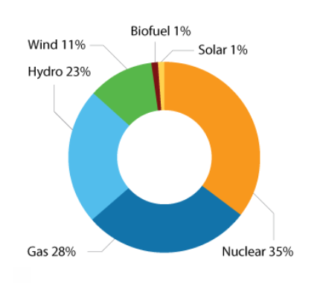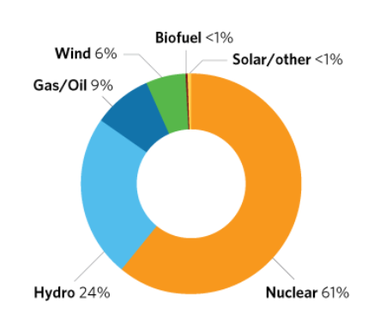
Ontario’s electricity supply mix in 2017 by installed capacity (left) and by power supplied (right)
Sometime in the 2020s, Canada’s top-tier capacity in nuclear technology will align with a huge global opportunity to provide sustainable, clean air energy. Canada will have the power to deliver on its own Paris Accord objectives and help the rest of the world do the same. Few or no other countries will have this same opportunity.
Grid-based new nuclear can take the form of large reactors, such as the Enhanced CANDU 6 reactor or large light water reactors, or in the form of small modular reactors. Canada’s home-grown CANDU reactor technology remains a top performer in electricity affordability, reliability and safety.
For reactors of all sizes, Canada (with government leadership) will want to set key criteria for technology selection.
For small modular reactors (SMRs), Canada is already recognized internationally as a particularly favorable market and regulatory environment. Establishing a leadership position early will enable Canada to secure a significant share of a projected $400 billion to $600 billion global market for SMRs to supply, not only electricity, but hydrogen (a clean fuel for transport applications or as a form of energy storage), district heating, desalination of seawater, coupling to energy storage systems, and process heat for industrial uses such as oil sands extraction and upgrading, steel manufacturing, and chemical production.
The path to deployment requires leadership as well as broad engagement and coordination across the many stakeholders. Community engagement and social acceptance will be a starting point. The agenda is much less about technology, and more about serving the needs of a human, social and environmental agenda.
Canada can take a leadership role in creatively and effectively utilizing this huge strategic asset we have in our nuclear industry sector and the potential to achieve real solutions to climate and energy poverty challenges. We in Canada have the expertise, the resources, the proven technologies, the regulatory framework, the experience of working with local and Indigenous communities, the creativity, the desire and the vision. It’s a question of will.
Now is the time to build momentum so the government’s agenda, and Canadians, can benefit from clean nuclear solutions. Our recommendations suggest where to begin, proceeding in partnership along the key pathways to a decarbonized and clean energy Canada.
Recommendations
Where to begin -- together
- Strong policy and programming support is needed from federal and provincial governments to position nuclear as an essential part of Canada’s clean energy strategy. This includes:
- clear policy statements reinforcing nuclear as an important enabler, alongside renewables and other energy sources, of Canada’s clean energy future;
- the exercise of the considerable influence of the government and the Prime Minister internationally to assert nuclear technology as an important part of innovation, clean energy, sustainability, economic growth and prosperity;
- recognize nuclear within clean energy fora such as COP 21/23, Mission Innovation and the Clean Energy Ministerial;
- support to Canadian nuclear businesses by facilitating access to: foreign governments and markets, financial supports through the Canada Account, Export Development Canada, and other government resources; and,
- support for agreements, licences and security requirements for the export of nuclear technology, uranium and fuel.

- Investment by industry and governments in nuclear innovation, including:
- government being an early customer, in particular, for very small reactors for military bases or other facilities, to lower the risks to the first private investor;
- investment by industry and federal and provincial governments in AECL and CNL for coordinated pan-Canadian research, development and demonstration of SMRs;
- creation of financial vehicles for governments and industry to share risks in advancing new technologies, such as public-private partnerships, and financial guarantees;
- involvement of stakeholders and end-users in all stages of technology development and marketing to ensure that innovation is connected to needs and demand; and,
- proper consideration of the full “cradle to grave concept” in technology development that takes account of full lifecycle costs, including full accountability for waste, and determining how spent fuel from new technologies will be integrated into Canada’s comprehensive waste management strategy.

- Work inclusively with indigenous people and all stakeholders, including by:
- beginning a dialogue now with indigenous and other stakeholders, leveraging the mechanisms and channels existing through INAC and other governmental and non-governmental agencies; and,
- exploring opportunities for business partnerships with indigenous peoples, communities and businesses to develop and deploy nuclear technologies.

- The government should provide ongoing support to the CNSC and possibly also to applicants, including:
- the financial support and ongoing autonomy necessary for the CNSC to continue to ensure the safety and security of the nuclear industry, and oversee the full scope of the nuclear lifecycle, including all aspects of environmental protection; and
- helping to offset some of the cost of licensing a new design.

- Ongoing coordination and dialogue between all stakeholders, including:
- the creation of a Nuclear Innovation Council (NIC), comprised of members from federal government departments and agencies, interested provincial governments, indigenous and host communities, as well as industry representatives. The council would provide advice and coordination on all matters relating to the nuclear sector and would be important in guiding the implementation of all other recommendations outlined in this report; and,
- the commissioning, perhaps by the NIC, of third-party experts to produce studies, analyses and recommendations to inform and support engagement and dialogue in critical matters, including operating models, affordability, fuel-cycle and waste management, procurement and demonstration; and
- a shared approach to fleet-wide efficiencies for the operation and maintenance of new reactor units to ensure there are adequate economic and social benefits across Canada.

