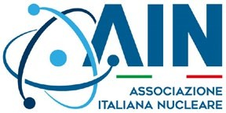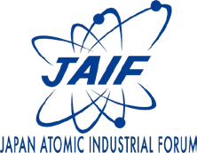
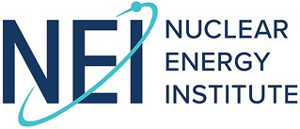
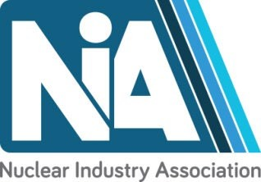

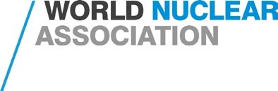

Nuclear industry statement to the G7 Ministerial Meeting on Climate, Energy and Environment in Turin, Italy (28-30 April 2024)

We, the industry associations representing the nuclear industry in G7 countries, and worldwide, welcome the opportunity to provide input to G7 Climate, Energy and Environment Ministers at their meeting in Turin. We are committed to ensuring safe and secure operation of nuclear facilities to provide always-on, affordable, clean low-carbon electricity and heat; to complement renewables in the pursuit of achieving net zero in electricity generation; to decarbonize hard-to- abate sectors, such as heavy industry, and to provide high-quality long-term jobs that drive economic growth.

Nuclear energy’s role to support climate change mitigation was unanimously agreed in COP28’s Global Stocktake, and 25 countries demonstrated greater ambition, setting a goal to triple nuclear capacity globally by 2050 in a Declaration during COP. Last month, at the Nuclear Energy Summit in Brussels, more than 30 countries, including six of the G7, reemphasized that nuclear energy has a key role to play to reduce greenhouse gas emissions, and ensure energy security and industrial competitiveness.

We applaud the recognition and support expressed for nuclear energy as a strategic global asset at the G7 meeting in Sapporo in 2023, and the actions that have been taken since. We welcome the commitment made by Canada, France, Japan, the United Kingdom, and the United States in pledging $4.2 billion to expand enrichment and conversion for secure fuel supplies, and their achievement in surpassing this goal.

We congratulate the Italian government on its hosting of the G7 meetings this year. Italian supply chain companies play an important role in contributing to nuclear development and deployment globally, as do companies in all G7 nations.

Today, G7 countries host more than half of the world’s existing nuclear capacity as well as the most promising advanced nuclear technologies. G7 countries have operational experience, fuel cycle capabilities, regulatory capacity, and financing ability that can support countries who are deploying nuclear power for the first time do so safely, securely and in a responsible manner to meet their climate and energy security goals.

We urge G7 governments to set out clear plans for nuclear energy deployment that would fulfil the targets they set at COP28 and to demonstrate their commitment to nuclear energy, giving clear signals to markets and investors.

We therefore encourage governments to help maximize the use of existing nuclear power plants, including by extending the operating period of reactors and restarting those that have shutdown, where feasible. Governments should accelerate the deployment of new nuclear facilities based on proven designs, and accelerate the development, demonstration, and deployment of new nuclear technologies, including new large nuclear reactors as well as Small Modular Reactors and Advanced Modular Reactors, to achieve net zero in electricity generation, and help decarbonize non-grid, hard-to-abate sectors, such as heat supply for heavy industry, hydrogen production and the manufacturing of synthetic fuels.

To help achieve these goals we call on G7 Climate, Energy and Environment Ministers to take decisive action in these key areas:

- Establish optimum conditions through consistent and coherent long-term policies that enable the extension of the operating life of existing reactors and facilitate fleet deployment of nuclear technologies.
- Provide clarity to investors on the funding and investment recovery mechanisms available for nuclear projects.
- Ensure ready access to national and international climate finance mechanisms for nuclear development.
- Ensure that multilateral financial institutions include nuclear energy in their investment portfolios—The collective influence of G7 countries would have a significant impact on the policies of multilateral financial institutions.
- Clearly and unambiguously label nuclear energy and the associated fuel cycle as a sustainable investment.
- Promote development of the supply chain commensurate with expansion targets and continue investment in nuclear research—Collaboration among the G7 nations and their partners is crucial for enhancing supply chain readiness, enabling efficient nuclear new build, ensuring quality, and achieving cost-effective equipment and services. G7 governments should accelerate efforts to develop supply chain capacity, particularly uranium enrichment and conversion for nuclear fuel supply, to ensure security and resilience.

Nuclear energy holds immense promise for the world, and the G7 should embrace nuclear deployment as a strategic priority in the years to come.

Turin, 28 April 2024

AIN (Associazione Italiana Nucleare) Stefano MONTI  President | CNA (Canada Nuclear Association) John GORMAN  President & CEO
Gifen (Groupement des Industriels Français de l’Energie Nucléaire)  Olivier BARD CEO | JAIF (Japan Atomic Industrial Forum, Inc.)  p.p. Akihito UETAKE Shiro ARAI President
NEI (Nuclear Energy Institute)  p.p. Carol BERRIGAN Maria G. KORSNICK  President & CEO | NIA (Nuclear Industry Association) Tom GREATREX  CEO
nucleareurope  Yves DESBAZEILLE  Director General | World Nuclear Association  Sama BILBAO Y LEÓN  Director General

